|  |  |
| --- | --- |
| **Practicum Case** |  |
| CPEN6220  Computer Networks & Information Security |
| **Computer Engineering** | **O221-CPEN6098-PH01-08** |
| ***Valid on*** *Odd Semester Year 2021/2022* | **Revision 00** |

## Learning Outcomes

* Basic concepts of network
* Concepts of create network environment
* Basic structures of network

## Topic

* Routing Techniques - Dynamic Routing

## Subtopics

* OSPF
* EIGRP
* RIP

## Soal

*Case*

1. Introduction

The weakness of static routing is when a network has grown larger, the network will be harder to maintain by the network administrator. Dynamic routing can be used to solve this problem. Dynamic routing is different from static routing where static routing needs the network administrator to manually enter the routing table. Dynamic routing allows the router to make its routing table automatically based on the network the router is connected with.

With dynamic routing, the router will learn and find the best route to deliver a packet from one network to another network. The network administrator can't decide the route taken by the packet because all of the routes have already been decided. There are different methods to decide those paths, some of those are,

* OSPF

OSPF or Open Shortest Path First is an algorithm used for dynamic routing. OSPF uses the Djikstra algorithm to find the best route. In OSPF, each router will make a Link State Packet where this Link State Packet will be distributed to all neighbors. Then each router will calculate the shortest path to all neighbors based on the routing cost. When a change is made, Link State Packet will be redistributed to recalculate the shortest path.

* EIGRP

EIGRP or Enhanced Interior Gateway Routing Protocol is a routing protocol where two routers will form a relationship and exchange routes. Keepalive packet is present between the two of them to let each side know when the other one is down or the link between them is down. EIGRP uses DUAL (Diffusing-Update-Algorithm) to do look-free-routing and calculate the shortest path.

* RIP

RIP or Routing Information Protocol is a routing protocol classified as Interior Gateway Protocol (IGP). This protocol uses distance-vector-routing. RIP works by sending information about networks connected to a router to all neighbor router every 30 seconds. Then, the receiver router will update their information based on the information previously given. Then that information will be redistributed to their neighbor until that information will return to the first router until each router has agreed on the best route.

1. OSPF

For example, we will be applying dynamic routing on the network below,

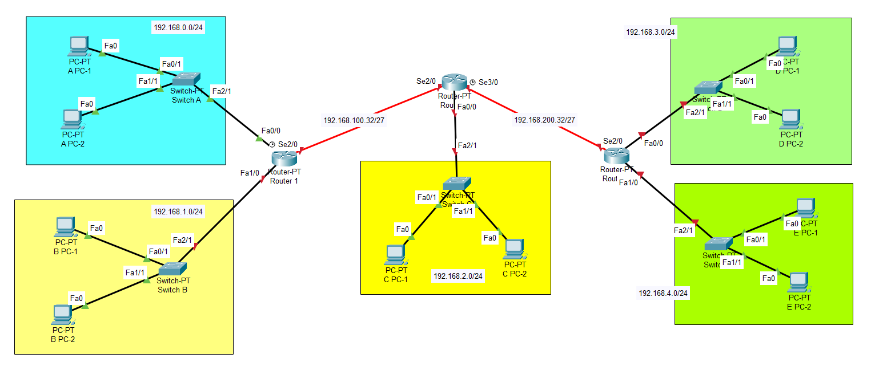

We want to connect every device in the above network using OSPF. To do so, we can follow the steps below,

1. Assign IP for each device (PC and Router)
2. Click on one of the routers, then go to the CLI tab.

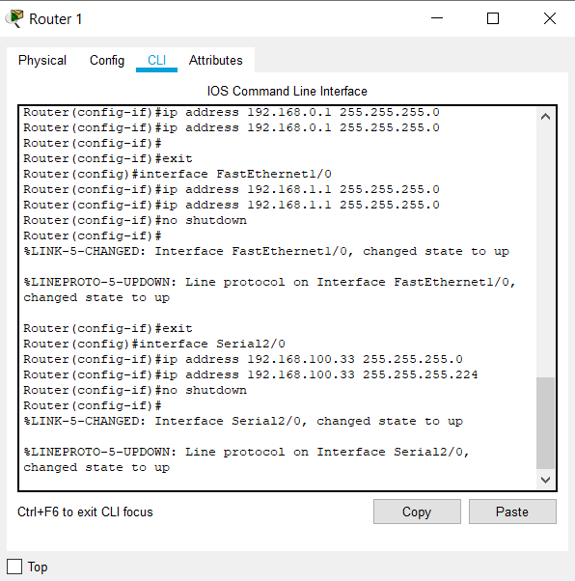

1. Enter the following command,

router ospf [process ID]

Process ID will be the desired number of process ID, for example, we will be using the process ID 5, therefore we will be entering the following command

router ospf 5

1. After that, we will be entering each network that is connected to the router using the following command,

network [network address] [wildcard] area [area ID]

Network address and wildcard will be according to the network that is connected to the router and area ID will be the desired number for area ID. For example, we will be using area ID 10, therefore we will be entering the following command. The following example is the command that will be inputted on Router 1, where the router is connected to 192.168.0.0, 192.168.1.0, and 192.168.100.32

network 192.168.0.0 0.0.0.255 area 10

network 192.168.1.0 0.0.0.255 area 10

network 192.168.100.32 0.0.0.31 area 10

1. Do the above steps for each router in the network
2. EIGRP

We will be applying EIGRP for the same network above. To do so, we can do the following steps



1. Assign IP for each device (PC and Router)
2. Click on one of the routers, then go to the CLI tab.



1. We will be using the following command

router eigrp [autonomous system number]

Autonomous system number will be the desired number for autonomous system number used for the EIGRP, for example, we will be using the ASN 5, therefore we will be entering the following command

router eigrp 5

1. After that, we will be entering each network that is connected to the router using the following command,

network [network address]

A network address will be all network that is connected to the router. For this example, we will be setting up dynamic routing in Router 1 first. Because Router 1 is connected to 192.168.0.0, 192.168.1.0, and 192.168.100.32, therefore we will be entering each of that network.

network 192.168.0.0

network 192.168.1.0 0

network 192.168.100.32

1. Do the above steps for each router in the network
2. RIP

To give an example of RIP dynamic routing, we will also be using the same network above. To do so, we can follow the below steps



1. Assign IP for each device (PC and Router)
2. Click on one of the routers, then go to the CLI tab.



1. We will be using the following command to start configuring RIP,

router rip

1. After that, we will be entering each network that is connected to the router using the following command,

network [network address]

A network address will be all network that is connected to the router. For this example, we will be setting up dynamic routing in Router 1 first. Because Router 1 is connected to 192.168.0.0, 192.168.1.0, and 192.168.100.32, therefore we will be entering each of that network.

network 192.168.0.0

network 192.168.1.0 0

network 192.168.100.32

1. Do the above steps for each router in the network
2. Case

Quantum & Clock is getting bigger and planning to build three new offices. Each office will be a three-floor building. Therefore, it will need some routing to be done inside. So, you as a network engineer are asked to make the network using dynamic routing. But, Quantum & Clock requested that you make each office with a different algorithm. Below is the topology for the network,

